**Using Meshlab to measure surface area from 3D models of coral samples**

Mote Marine Laboratory

Coral Health and Disease

Written by Eleftherios Karabelas

Adapted from Million and Kenkel, 2021

Last Updated: 09/22, EK

**\*\* IF YOU HAVE POOR FRAMES PER SECOND: UNDER SHADING ON THE BOTTOM RIGHT CLICK NONE\*\***

We will be using the open-source software MeshLab ( <https://www.meshlab.net/#download> ) to compute geometric measurements of the 3D coral models made in AGI Metashape. Each model file contains 2 sample coral, therefore processing a single model file will require multiple “runs” as we must crop out all but one of the models to get a surface area of the coral sample. The process is broken down into the following steps:

1. **Import mesh file (.obj file)**
2. **Record the genotype and replicate code (e.g. AC31-C14) you are going to measure**
3. **Set Scale using rulers from model**
4. **Export Scaled Model (for first run of a model)**
5. **Crop out coral mesh that you are not measuring on this run**
6. **Export mesh**
7. **Minor hole filling**
8. **Compute geometric measures**
9. **Record Surface Area of mesh and record to the Master Spreadsheet**

The subsequent runs will consist of the same steps; however, we will export a scaled version of the model so you will not have to reset the scale on the later runs. You will open the scaled model that you saved in the first run and resume the protocol after the set scale step.

1. **Import mesh into MeshLab**

* Open the MeshLab application, and either Press “control + I” or click on file and select “Import mesh”.
* Navigate to the “models” folder where the .obj files were exported from Metashape.
  + Each treatment should have its own models folder (longterm OW, CBASS, etc.) where the mesh (.obj) and texture (.png) are stored.
* Select the .obj file and wait for Meshlab to load the file.
* Check that the model looks correct, has a legible rendering of the genotype card, and has both corals (if 2 are present).

1. **Record Genotype and Replicate information**

Since we are working with multiple coral models in each mesh file, we need to keep track of which coral we are processing as we will be deleting the rendered label for the calculations. The file name will contain all genotypes, but sometimes not the replicate number. Write down the information of which of the 2 corals you are about to measure. This will help you keep track after we begin cropping and do not have the info card rendering to reference.

1. **Set the scale of the model**

When the model is exported from MetaShape it is not scaled to the true proportions of the coral it was built to model, we need to do this first in MeshLab so that the measurements we compute are accurate to the real world. Each mesh rendering has 2 rulers that we will use to set the scale.

* First you want to position the “camera” on one of the two rulers by double clicking the area of the ruler you are going to use.
* Next you want to maneuver the camera to be looking as close to perpendicular as possible
  + This makes drawing the measuring line easy and most accurate.
* Click on the measuring tape icon on the tool bar, the cursor should change to a crosshair.

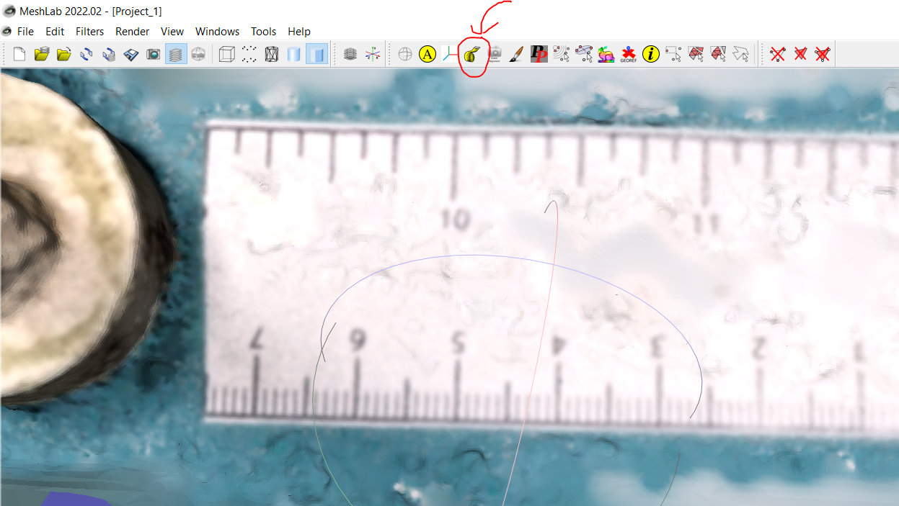

* With the crosshair, measure one cm by clicking on a hashmark on the ruler, and drawing a straight line across to the next hashmark and click again to set the endpoint.
  + 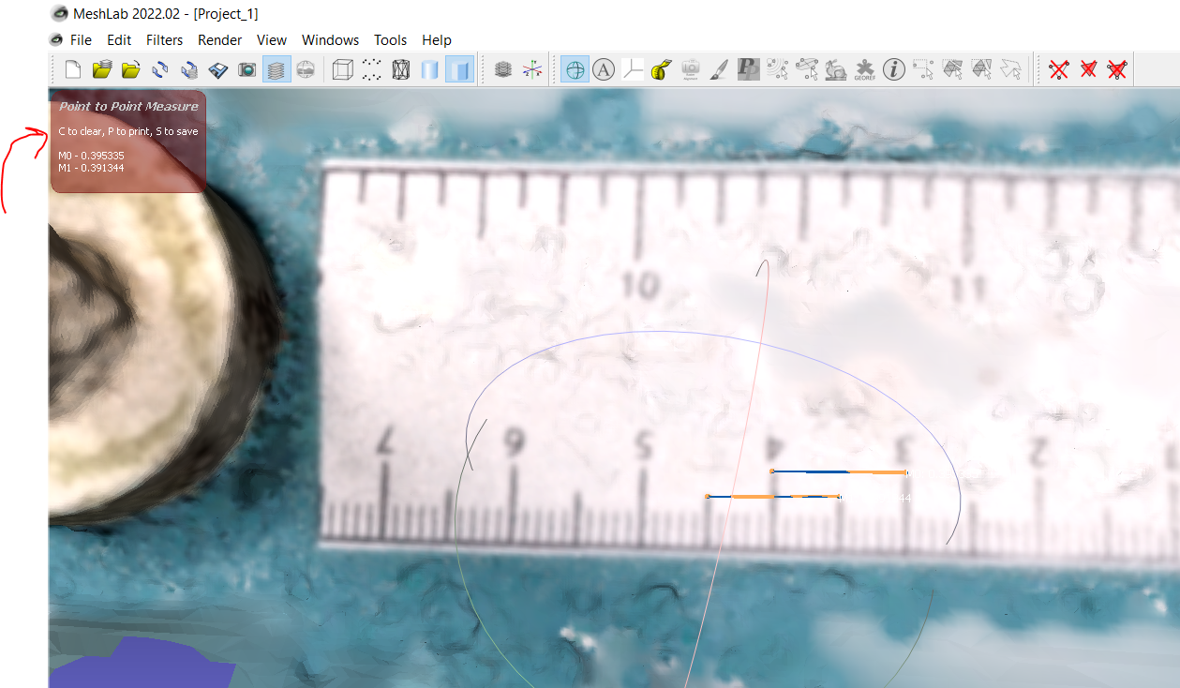In the top left corner, a red box will appear with the linear distance of the measure.
* Repeat this again so we have 2 recorded measurements to set scale.
  + The first one should be one entire centimeter on the ruler, Seen in the picture connecting 3 to 4 above.
  + For the second measurement you can either pick a different full centimeter or do a “half-to-half” measurement like in the example photo.
* Once you have two measurements, they should be quite close, average them and **write down the value**.
  + 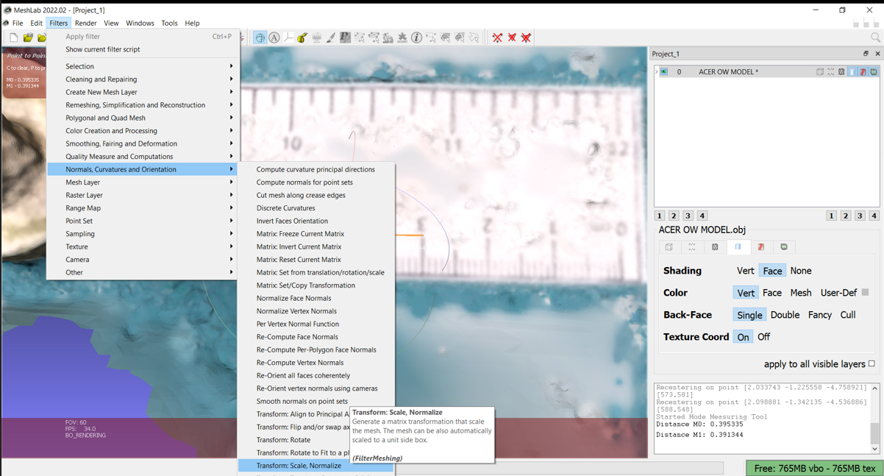**When you open the scaling dialogue box, your two measurements will disappear so average them and record it before you proceed.**
* Navigate to the filters dropdown and hover over “normals, curvature, and orientation” to show the submenu where you can find “Transform: Scale, Normalize” and select it. The scaling dialogue box will open.

**Calculate the scale factor using the average you recorded from the previous step by dividing 1 by the measured average of M0 and M1. For example: in the pictures M0= 0.395335 and M1= 0.391344. (0.395335 + 0.391344) / 2 = 0.3933395 which we will plug in to: 1 / 0.3933395 = 2.542330 – This is our calculated scale factor.**

* Plug in the calculated scale factor into “X Axis” (as we measured the scale along the x axis on the ruler).
* Verify that “apply to all visible layers” and “uniform scaling” are selected, and then click apply.
* 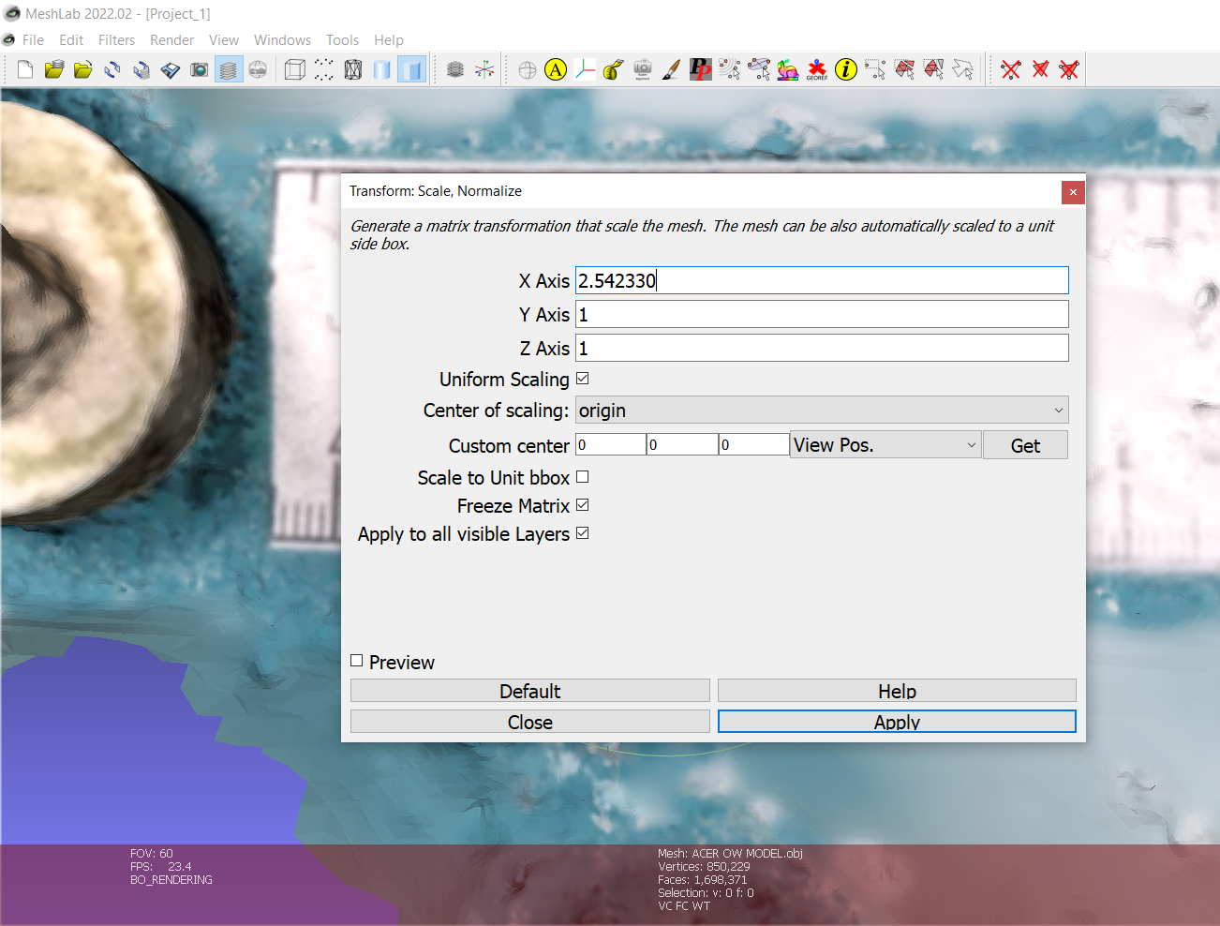 The model will be scaled, and you can click close on the dialogue box. The camera position will probably have changed, and you may need to reorient yourself with the newly scaled model.
* 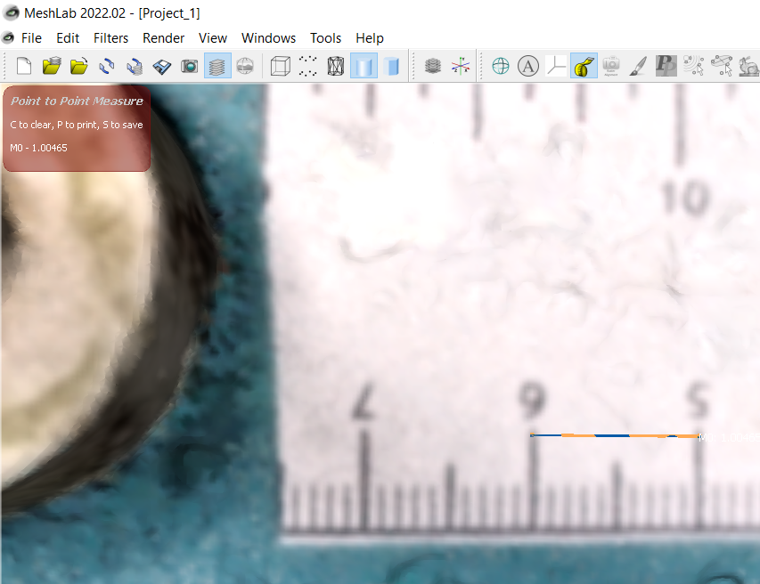Use the measure tool to verify the scaling processed accurately by measuring 1 cm again on the ruler
  + here we get 1.00465 indicating the scaling was a success! If your measurement is more than a few decimals off 1.00 you will want to go back and repeat the process of scaling.

1. **Export Scaled Model**

Now we want to export a new version of the mesh that is already scaled so we will not have to rescale this model again on the second run:

* go to file > Export Mesh As...
* Leave the file name intact but add “_SCALED” to the end of the file name.
  + e.g., if this file was named AC31-C17_AC41-C17.obj we would want the new mesh to be saved as **AC31-C17_AC41-C17_SCALED.obj**.
* Make sure you save the file type as wavefront obj (.obj) you may have to select it below the file name as it is not the default.

1. **Crop out Coral we are not measuring on this run  
   Method one: Paintbrush method for planar growth frags (APAL, OFAV, etc.)**

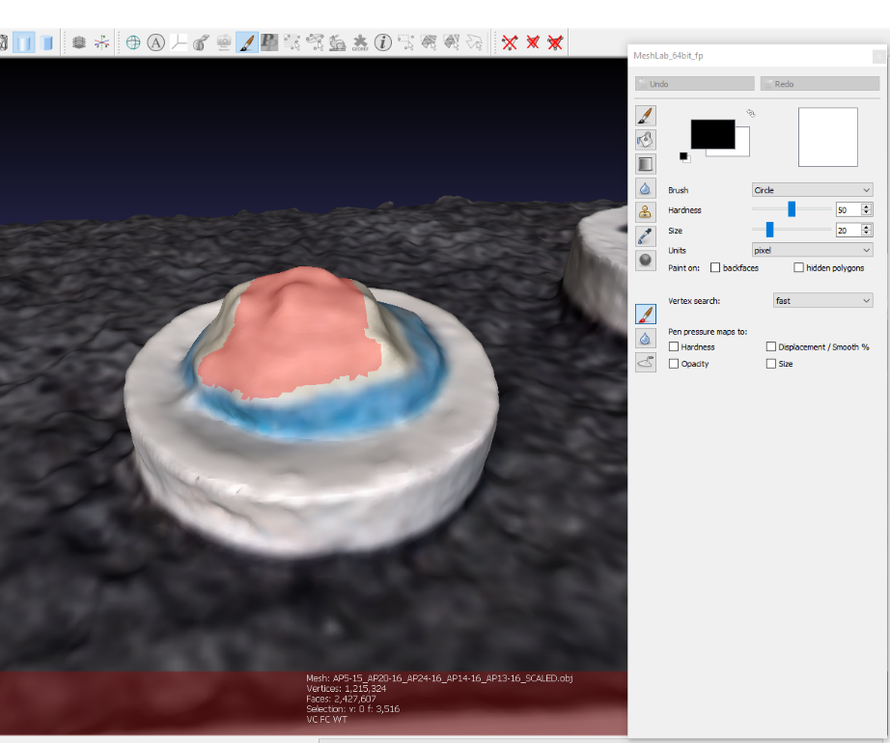First step of cropping will be to remove every part of the mesh that is not the coral we are measuring. Log the ID of the coral you will measure on the spreadsheet if not already done and be sure you are working on the right coral in the model.

* Select the paintbrush tool from the toolbar and then click on the red brush located 3rd from the bottom of the vertical toolbar of the brush dialogue box
* Paint the coral with the mouse and holding left click to paint a selection mark on the coral we are measuring. Take care to completely paint the coral and constantly rotate to make sure you are getting all sides of the model.
  + If you over-paint an area you didn’t mean to: simply de-select by painting it with the mouse again but this time holding down right click instead of left click
* 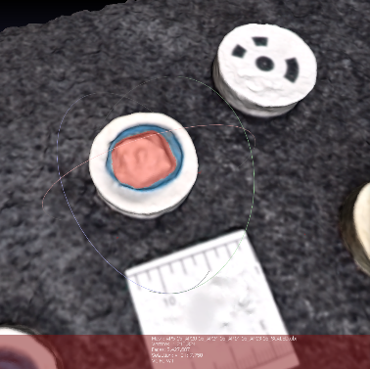In the brush dialogue box you can adjust the size of the paintbrush circle, making it smaller for control in areas of detail and the boarder of the coral/plug interface where precision is needed.
  + The coral-plug interface is sometimes difficult to distinguish between, just make your best effort especially if the overall sample is small, a big variation here will significantly change the surface area!
* Once the coral is fully selected and painted red with the selection tool, rotate fully to verify you did not miss any spots, or any holes exist on the coral
* 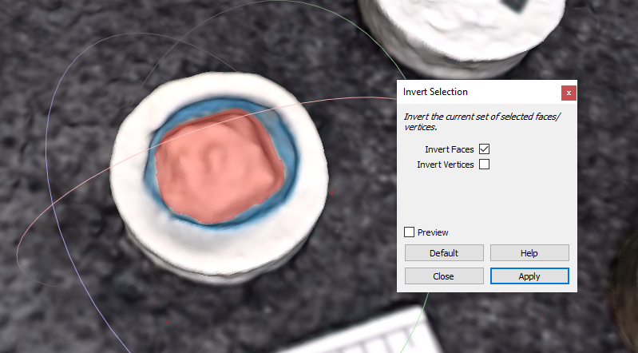Press “ctrl + shift + I” to open the invert selection box
  + Make sure invert faces only is checked (for paintbrush method)
  + Press “apply”
  + Close the dialogue box
* Now we told Meshlab to select everything EXCEPT what we had just painted (every part of the model except our coral!)
* 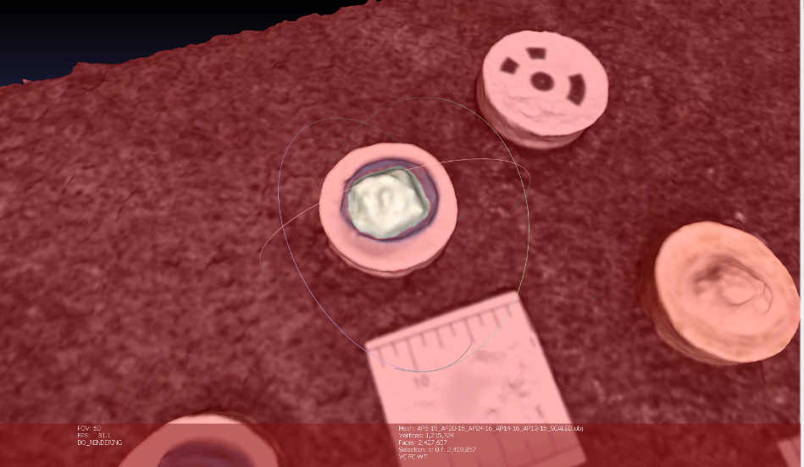After verifying that everything has been selected properly, click the “delete selected faces and vertices” icon 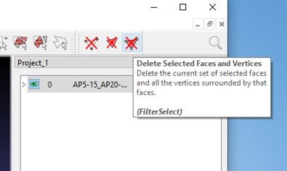
  + Just our coral sample floating in a void should exist now
* Clean up any errant particles or artifacts from model creation

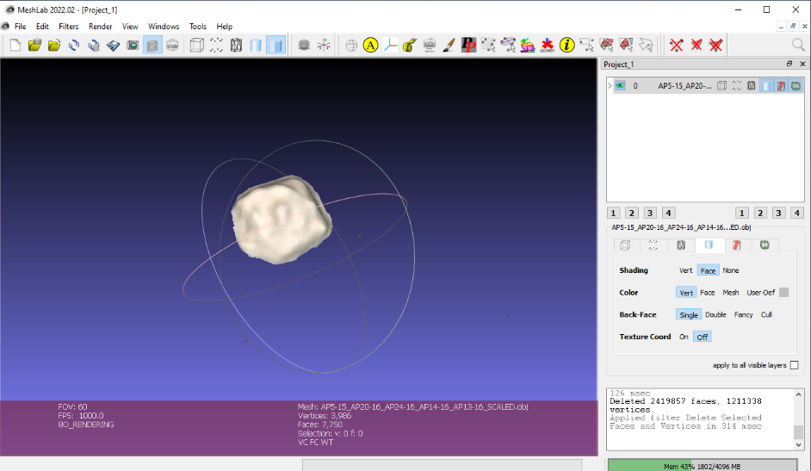

**Method two: Select vertex method for complex frags (ACER, mature APAL)**

For large cropping and to remove errant particles at the end we will use the select vertex tool from the toolbar. This only lets you select in a rectangle shape but be careful as this tool will select all faces behind any mesh as well. Take care not to select and delete anything that may be behind something in the mesh. This is perfect for complex branching frags though, as manually painting all sides would be very time consuming!

* First orient the frag of interest so that there is nothing behind it in the model and your viewpoint is level with the plane of the model platform
* 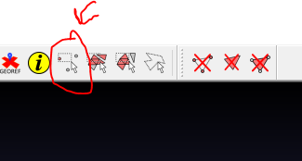Click the select vertices icon from the toolbar to activate the rectangular selection tool
* With nothing but void behind the frag of interest click and drag to create a rectangle around the whole frag as well as the top ¼ of the plug its mounted on (if it has begun encrusting)
  + This is why we want to be level with the plane of the platform
* 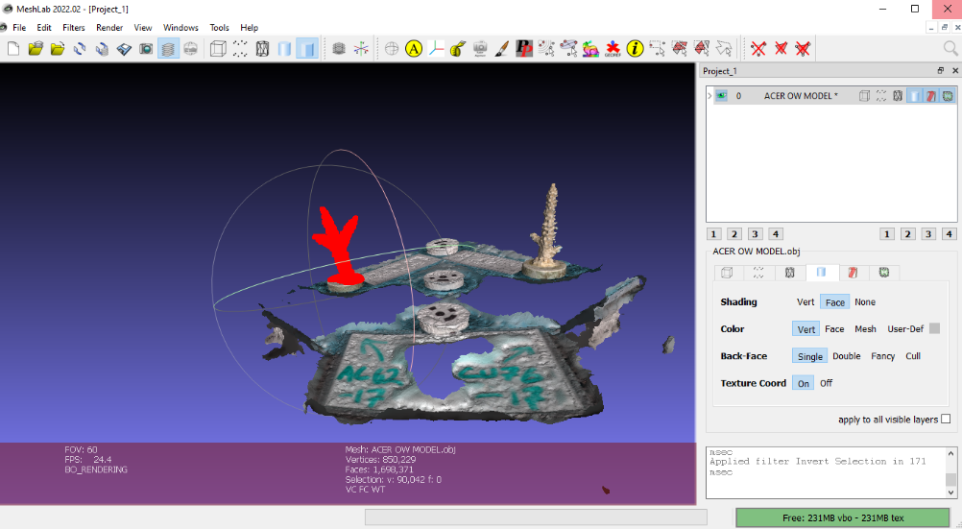Release the mouse click to complete the selection
* Just as in the paintbrush method, press “ctrl + shift + I” to open the invert selection dialogue box
  + For this method it is the reverse, select only “Invert Vertices”
* Again, everything except the frag of interest will be highlighted with the selection indicator now after clicking apply
* 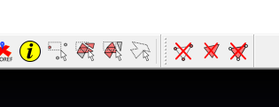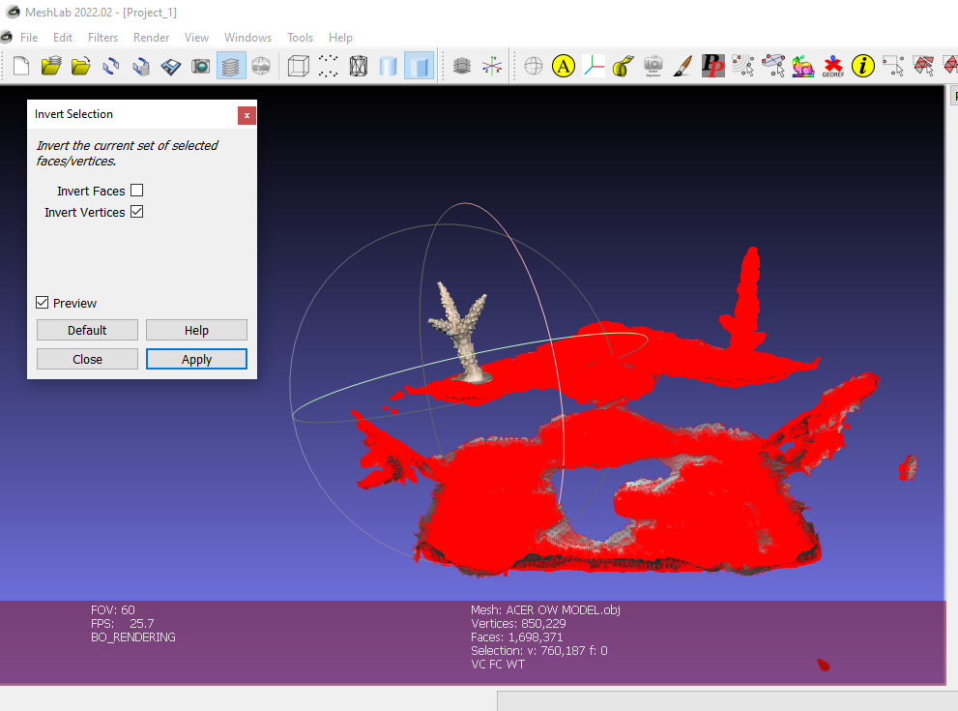Verify all parts of the coral of interest are now not selected and press the delete “selected vertices” box
* All that is left is to clean the remaining mesh of the coral of interest by removing the parts of the plug that remain.
* Follow the paintbrush technique in method one to finish up  
    
    
  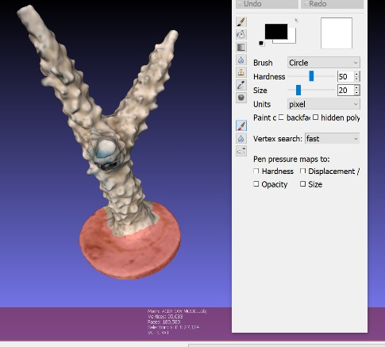  
  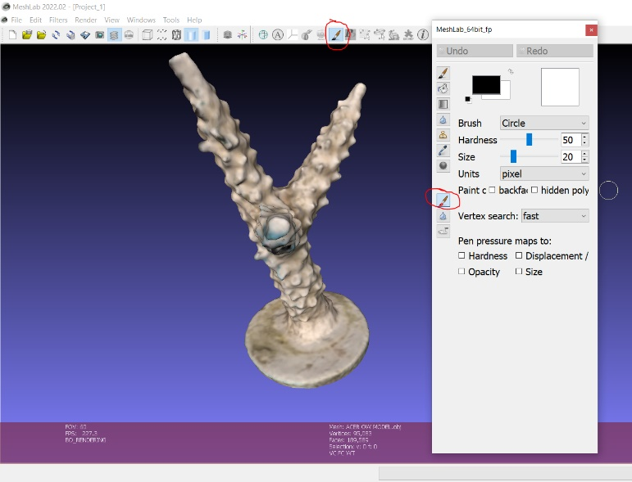
* 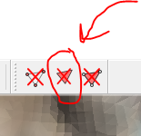Press escape to get the navigation ball back to rotate the mesh and get access to all sides and use “delete selected faces” to delete what you have selected.
* Now we should be left with a mesh that contains nothing but the coral

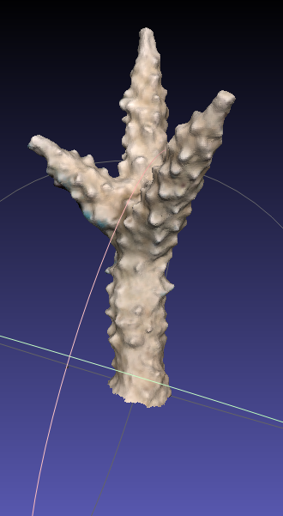

1. **Export scaled cropped mesh**

If we encounter any problems we will want to have the cropped mesh saved so we do not have to waste time re-cropping the full model again.

* Again, go to file > Export Mesh As… and save a copy of the fully trimmed mesh.
* In the file name delete the information of the coral you cropped out, so it the last export was named AC31_C17_AC41_C17_SCALED.obj, and this model is AC31_C17, the file should be AC31_C17_SCALED.obj and click save.
  + Now if anything goes wrong you have a copy of the coral already cropped.

1. **Minor Hole filling**

The models should not pass QC with any holes, but as a precaution we will have MeshLab do hole filling.

* Go to Filters > Remeshing, Simplification, and Reconstruction > Close Holes. In the dialogue box the default is 30, change it to 50 and click apply then close the dialog box.
* Just verify that the bottom of the coral mesh wasn’t closed, and we are ready to get the surface area (finally!)

1. **Compute geometric measures**

The last step is to have MeshLab compute the surface areas, and good news its super easy! Go to Filters > Quality measures and computations > Compute Geometric measurements. That’s it!

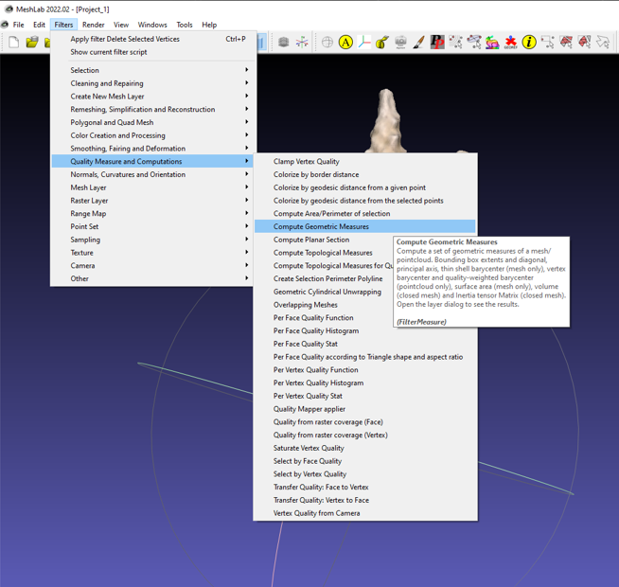Now look at the bottom right hand console, all the calculations are now recorded. Scroll up until you see Mesh Surface Area is “X” and record that number. This is our surface area in cm2 as we scaled our model to 1 cm.

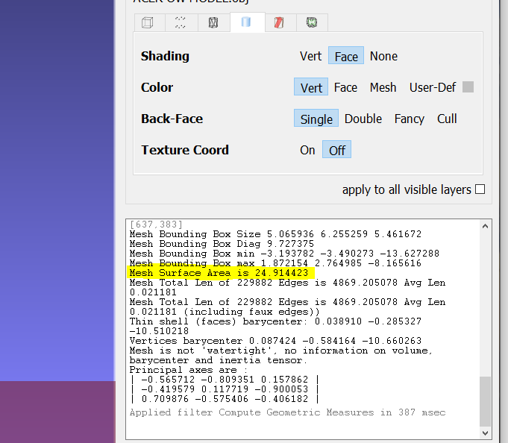

1. **Record Surface Area of mesh and record to the Master Spreadsheet**

Now just open up the full, already Scaled model mesh you exported from step 4 and carry out the protocol for the remaining coral that you cropped out before.